Published: 08:17 AM, Mon Oct 22, 2012
Hasty: Cococnut cake repays a 47-year-old debt

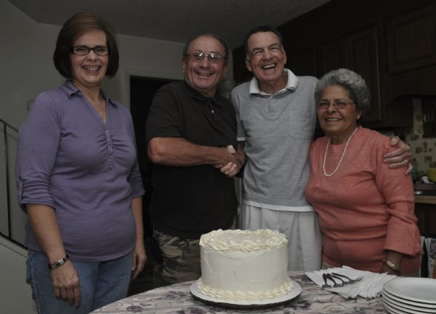
Staff photo by Marcus Castro
Sheila Hanrick, left, from Kiss Me Cakes, delivers a coconut cake to James Bledsole. Standing next to James are a buddy he served with in Vietnam, Frank Oxendine, and his wife, Carolyn.
Kim Hasty
HOPE MILLS - In a cozy small-town kitchen, around a table set with coffee cups and nice paper napkins, a 47-year-old debt was repaid last week.
In the middle of the table was a coconut cake, similar to one that had arrived in 1965 thousands of miles from here. That cake had been delivered into a nightmare setting that neither of the two men sitting around the table will ever forget.
"It was some pretty serious stuff that happened over there,'' one of the men said.
The long-ago coconut cake delivered into the brutal terrain of Vietnam was amazing for the good condition in which it arrived.
Handsome young James A. Bledsole, good-naturedly kidded for his sparkling blue eyes, was turning 21 years old while fighting for his country. His mama had baked the coconut cake, his favorite, and shipped it all the way from Robeson County.
"She was a country cook,'' Bledsole remembered. "Everything was pretty much made from scratch, starting with cracking the whole coconut.''
Bledsole was a member of Delta Company, 1st Battalion, 12th Cavalry, 1st Cavalry Division, the first major divisional force deployed to the central highlands of Vietnam. When the USS Geiger arrived in September of 1965, each company drew straws to see which would go ashore first on the beaches at Qui Nhon. Delta Company won.
"These were kids who had come to us from all parts of the country,'' said retired Col. John Gergulis, commander of D Company. "We trained them at Fort Benning, Ga. Sixteen months later, we deployed to Vietnam. I have to tell you, they performed magnificently.''
Bledsole's duties included a stint as Gergulis' driver. It was during that time that the cake arrived from home.
"Jimmy offered to share the cake with the first sergeant and myself,'' Gergulis said. "He carefully deposited the cake in between the two front seats of our jeep for safekeeping.
"The taste of that very special cake still lingers after all these years.''
So delicious was the cake that Gergulis admits to having made his way back to the jeep for several clandestine bites. The cake was gone in short order.
And the years passed.
Bledsole left the Army for a career at Kelly-Springfield Tire Co. in Fayetteville. Gergulis, a captain during the Vietnam years, spent a career in the Army before retiring as a colonel.
The two didn't see each other again until the men of Delta Company organized their first reunion, after all these years, last month in Branson, Mo.
Gergulis' wife, Babes Gergulis, listened as Bledsole laughingly reminisced about the coconut cake that had so quickly disappeared.
"I said, 'We owe this man a cake,' '' she said.
She returned home to Melbourne, Fla., and got busy on the computer. She eventually found Sheila Hanrick, owner of Kiss Me Cakes on Legion Road.
Hanrick agreed to bake a coconut cake, and to deliver it, as well. In a twist, the cake would go not only to Bledsole but also to fellow D Company comrade Frank Oxendine. Until the reunion, the two had never realized that they both live in Hope Mills, just a few miles from each other.
So it was that Hanrick brought the cake to the Oxendines' home Wednesday. Carolyn Oxendine set the table and put on a pot of coffee.
Bledsole did the honors, cutting into the rich and creamy layers and proclaiming this version as decidedly delicious.
And though Hanrick refused to take payment for the cake, it nevertheless seemed that the debt of the coconut cake had been satisfied.
"If a piece of cake can bring back a happy memory in a warrior's life,'' Babes Gergulis said, "then that's all that matters.''
Community news editor Kim Hasty can be reached at hastyk@fayobserver.comor 486-3591.

